Kenmore Rotary Club- The Rotary Clock Story
by Brian Becconsall- 6-10-2022
In late 1997, Kenmore Rotary club installed a 4-sided Rotary Faced clock in the Kenmore Village Shopping Centre. The substantial faces are 600mm in diameter, and of very robust construction, and can be read at a considerable distance. A press release by then club president Lance Weller at the time sums up the reasons:
Kenmore Rotary decided ‘it was time to say thank you’ to the people of Kenmore for their support over the years. They have done this by presenting a clock to the Kenmore Village management. For many years the Rotary Club of Kenmore has been a major supporter of the Kenmore community. Most of their work is done ‘behind the scenes’ with little publicity. Projects such as the formation of Kenmore Meals on Wheels, the donation of a fully equipped ambulance to the Kenmore Ambulance station, a donation of $30,000.00 towards the mammography unit at Wesley Hospital and initial funding for the construction of the swimming pool at Kenmore Primary School have all benefited from funds raised by Kenmore Rotary. This year, as a way of saying ‘thank you’ to the local community for their support, Kenmore Rotary has donated a clock to Kenmore Village as one of their Community Service projects. The four-sided clock, in the form of the Rotary wheel, hangs in the atrium area of the Village shopping centre. Kenmore Rotary President, Lance Weller, in handing over the clock to the Village Centre manager Leisa Blair, said “This project is in response to many requests from residents and shoppers for a clock in the Centre. It is one way in which Rotary can thank the community for its support over the past 28 years.”
It was supported in the atrium high ceiling area in a central location at the intersection of the 4 internal avenues close to the Moggill Rd entrance and cost the club $4780 installed.
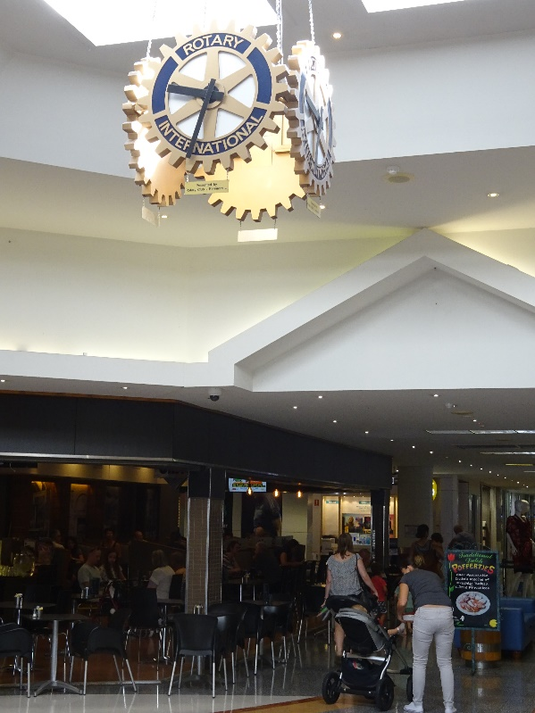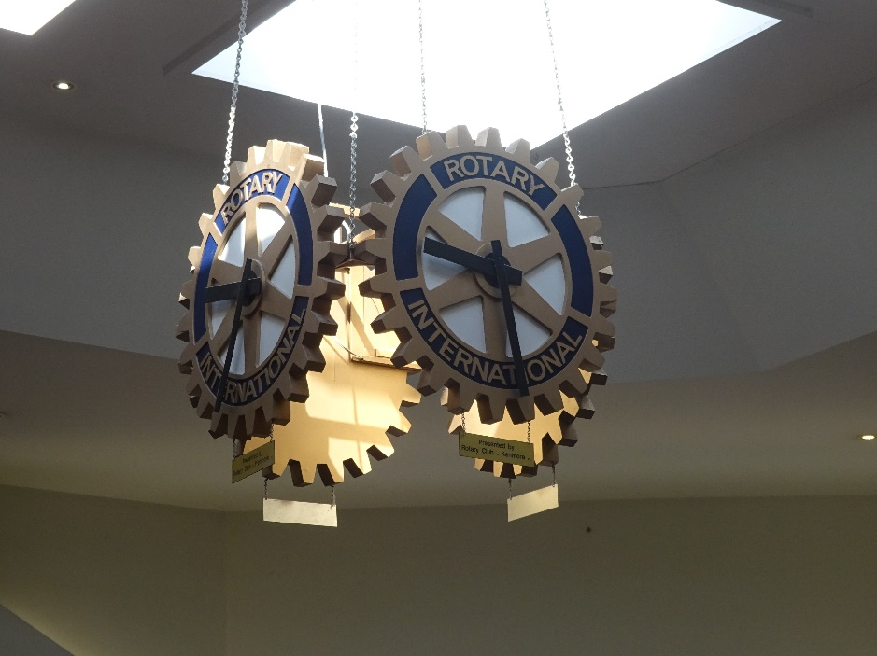
Clock as it was in March 2017 before dismantling.

It was designed by former member Russell Bennett, a retired Elec. and Mech. Engineer, and supplied by the Sychronome Clock Co. with a dedicated 240 v power supply and controls to keep all 4 clocks in unison. It was a popular meeting place at the Village, and the only public clock installed there. In 2018, after 20+ years of service, the Kenmore Village Centre management decided to remove the clock due to “unreliability issues and the need to redecorate the centre”. It was presented back to the club, and with Russell Bennett now deceased, Club president Ken Ryan asked member Brian Becconsall to work out future possibilities. Brian proposed converting all 4 clock faces to independent battery operation, and with Geoff Haigh, attempted to find local venues where it would be appreciated. This was completed with new hands installed at minimum cost, and the first 2 clocks were presented to commemorate the clubs 50 th anniversary year in 2019 to:
No 1- Bolton Clark Fairview-Residential Aged Care – Pinjarra Hills- June 2019- (The club has had several members become residents at Fairview, and has been a supporter of the centre. Present at th handover by Ken Ryan was Brian Stevens, a charter member of the club in 1969 and a resident at the time as well as Russell Bennett’s widow Val Bennett)
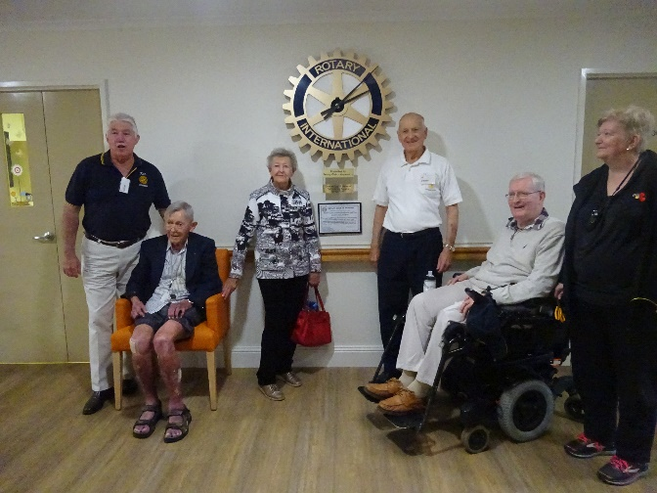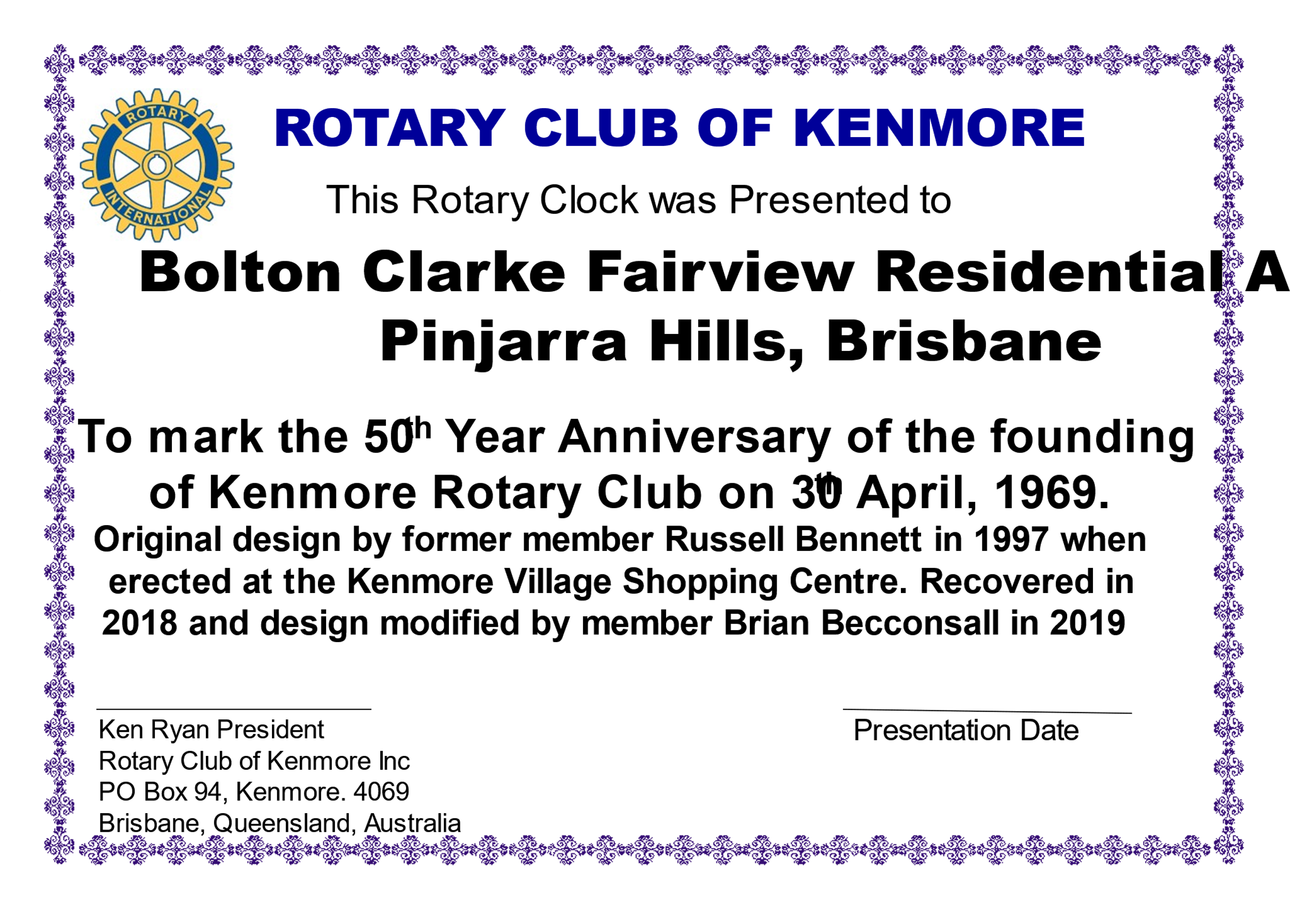
No 2- Glenleighden School, Fig Tree Pocket- Aug 2019- (The club had a long history with this school, with working bees and donations and club member, Architect Ray Giarola, completing many extensions with his private professional practice.)

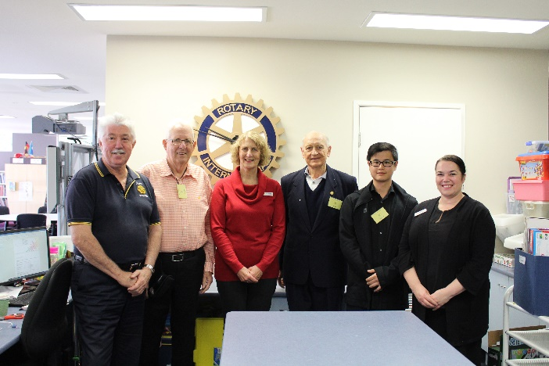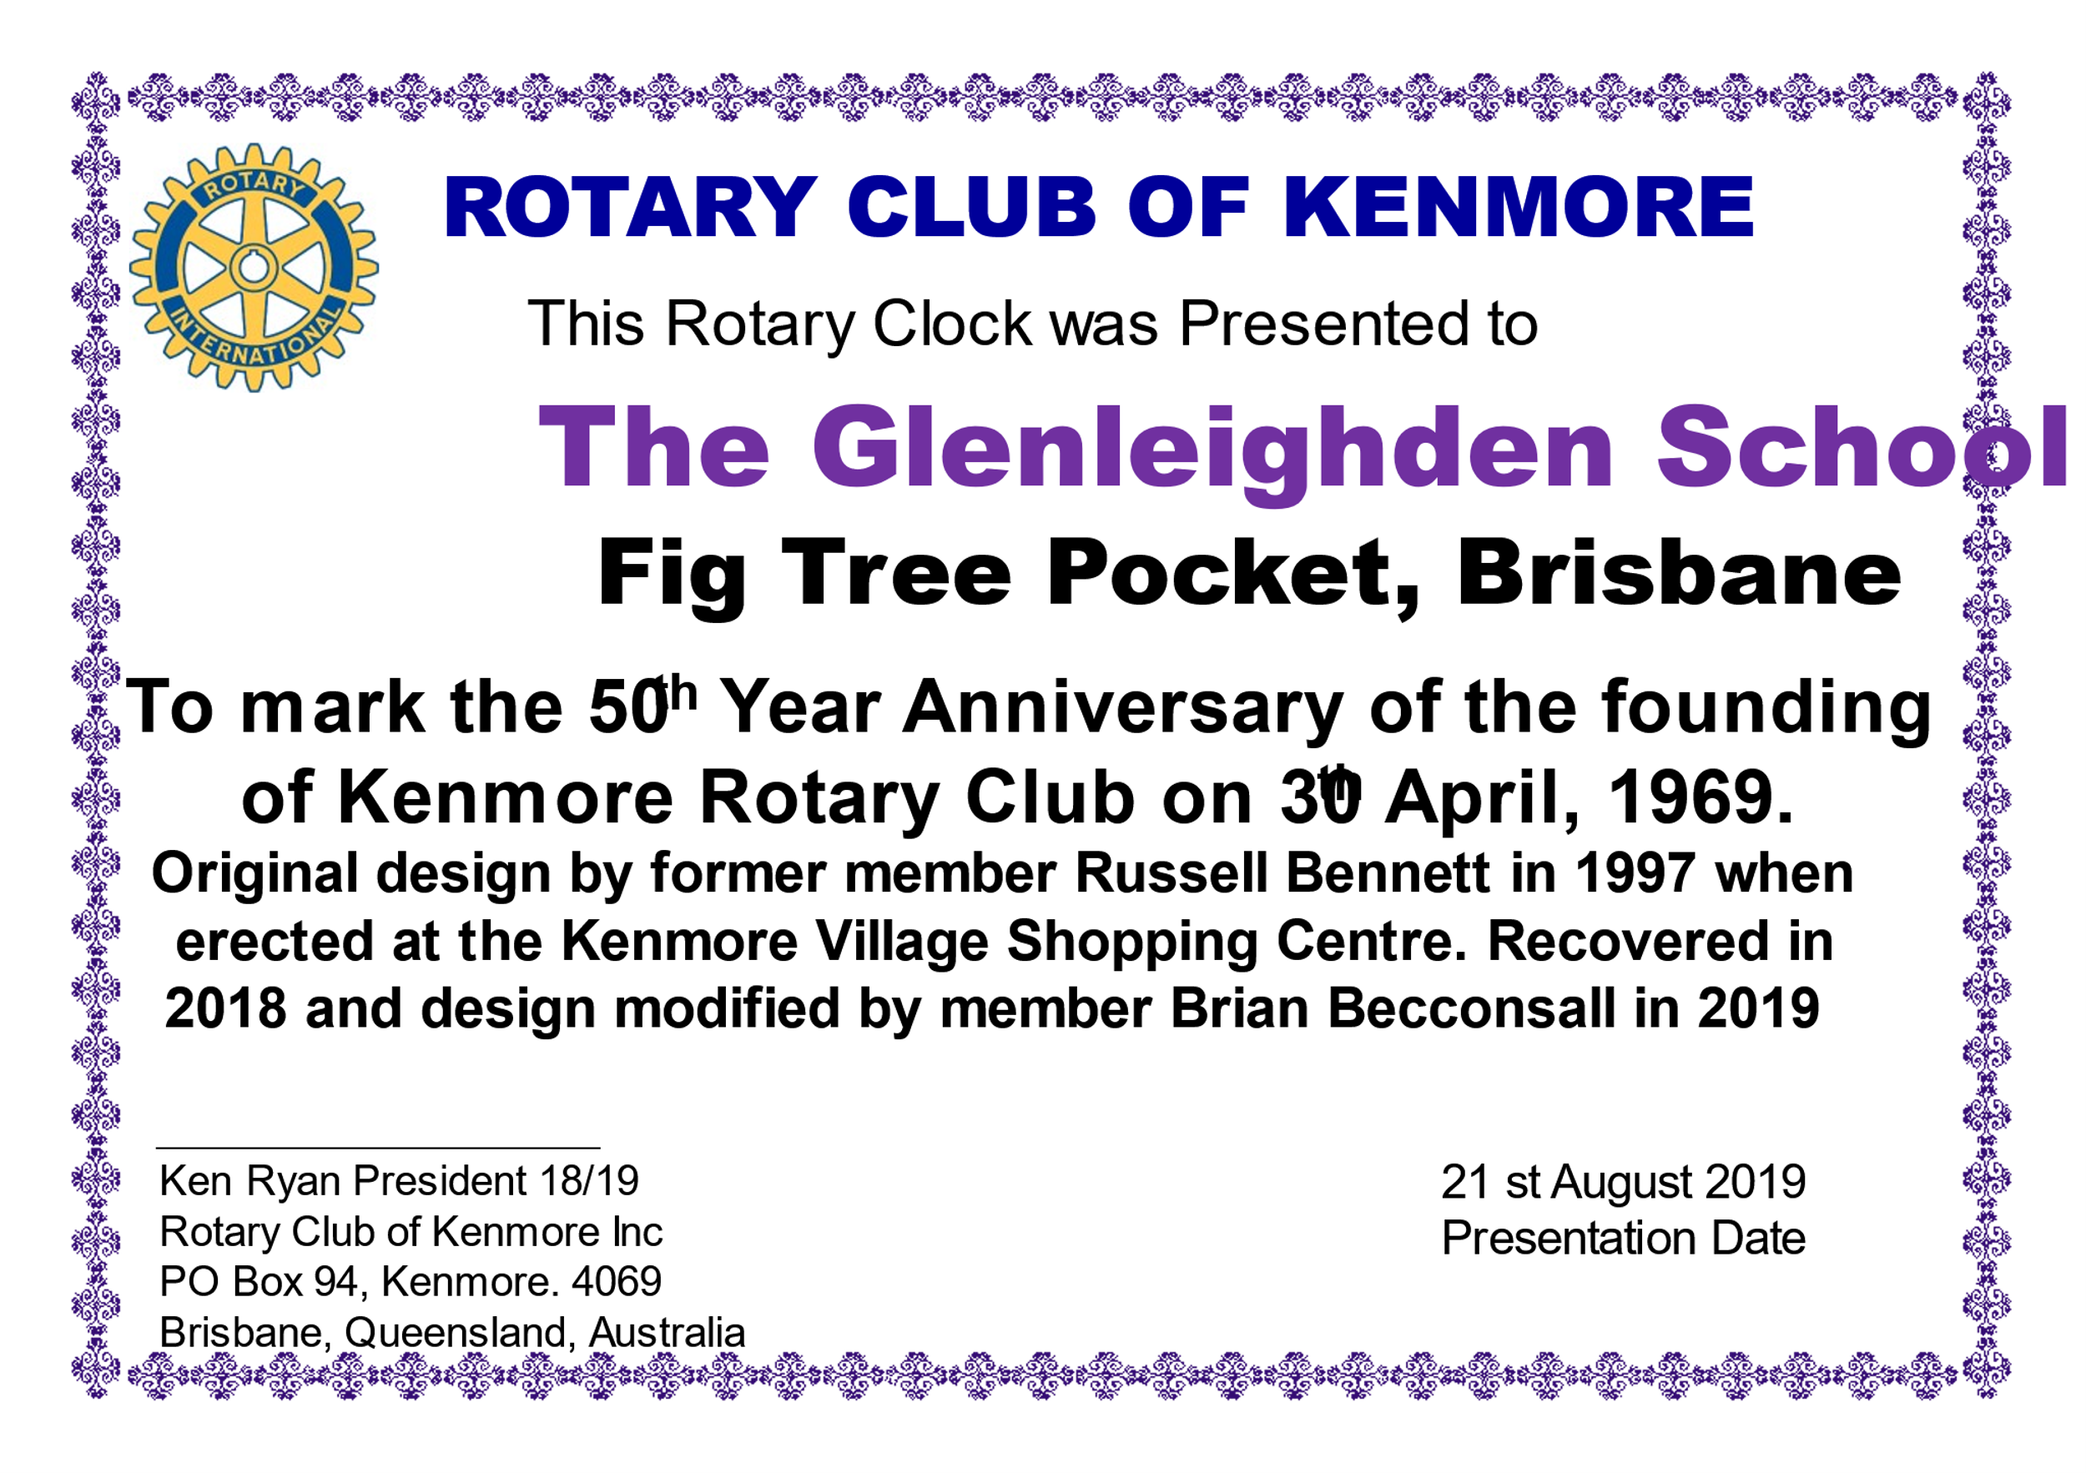
With the onset of Covid, the next 2 clocks were delayed, and the next presentation was:
No 3- Iona Nursing Home, Kenmore Hills – Sept 2022- (The club has supported Iona with a men’s discussion group started by past member Trevor Webb with Past President Geoff Haigh in 2002, and this has been re-established in 2022)

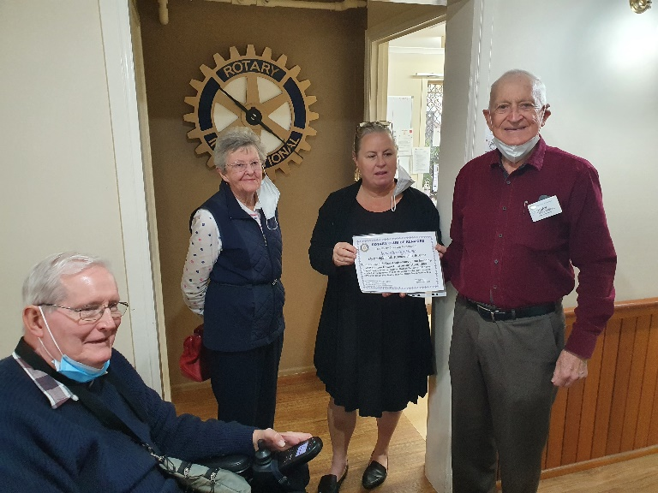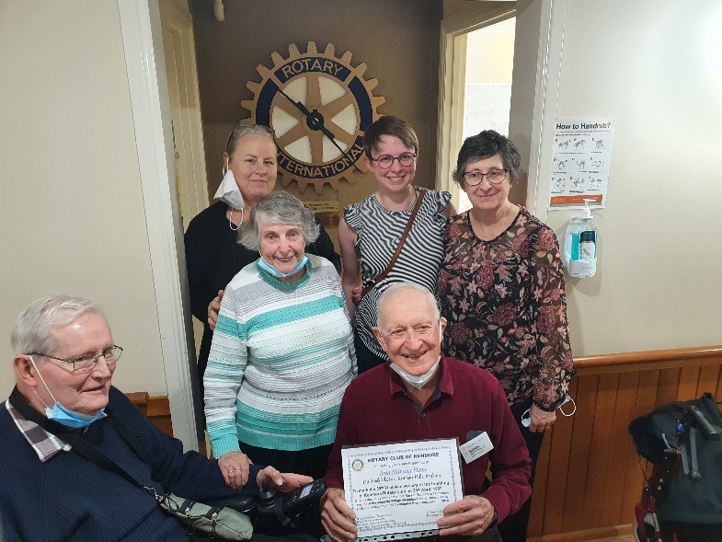
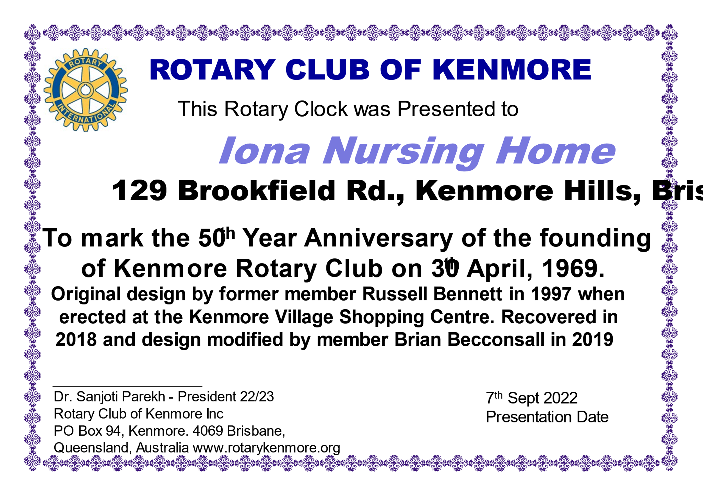
No 4- Cairns Aged care Centre- Salvation Army- Moggill Rd Chapel Hill, awaiting approval from their management for finding a suitable location in the centre (The club supported the previous Salvation Army ALKIRA Boys Home in the 1970’s 80’s with donations- It is now a high care centre and when it was established in 2011, during the big Brisbane floods, the club provided extensive rosters to provide in house help with catering support etc through member and later Past President Alan Biggs-his son in law was managing their care centres).
Summary.
Over the past 27 years, the Kenmore Rotary Clocks have provided a service to the local community in appreciation for the support that the community provides to the club. It is hoped that they will continue to operate and be a Rotary link into our community.

