Kenmore Rotary Club- The Rotary Park Seat Project 2015
Concept
In late 2013, the BCC announced that a $3m Suburban Community Improvement Project (SCIP) was planned for Moggill Rd/Brookfield Rd Kenmore opposite the Kenmore state school. This was the first footpath improvement in the 40+ years in living memory, so I made enquiries if there could be opportunities for Kenmore Rotary to have a small presence in the public footpath space. At the Civic Cabinet Community meeting at Kenmore in March 2014, I received a favourable response from Amanda Cooper, Chairman for Neighbourhood Planning & Development Assessment Committee to start negotiations with the BCC.
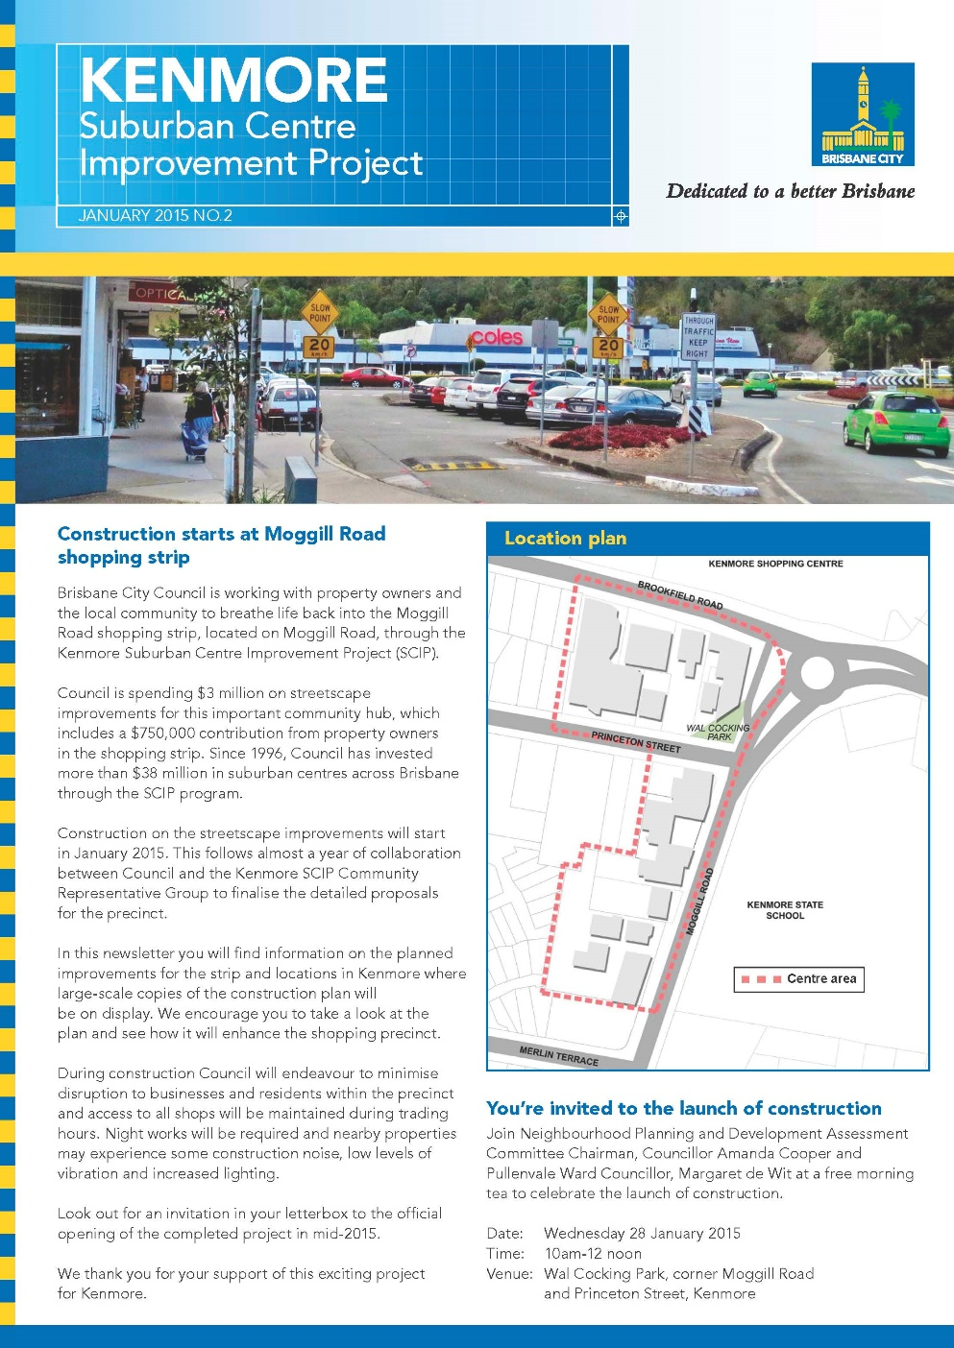
Preliminary Investigations.
I received 2013/14 Club President (Jim Dalton) approval to proceed with Ray Giarola into liaison with BCC and investigations into what form our contribution might take- Gardens, Seating, landscaping etc. with appropriate signage to publicise the name of our club. This was narrowed down quickly to a modern timber outdoor seat, with our club’s name engraved in the timber slats acceptable to BCC. A footpath location in the central area was initially proposed, and negotiations continued with Clare Hannah, Urban Designer on the SCIP project team.
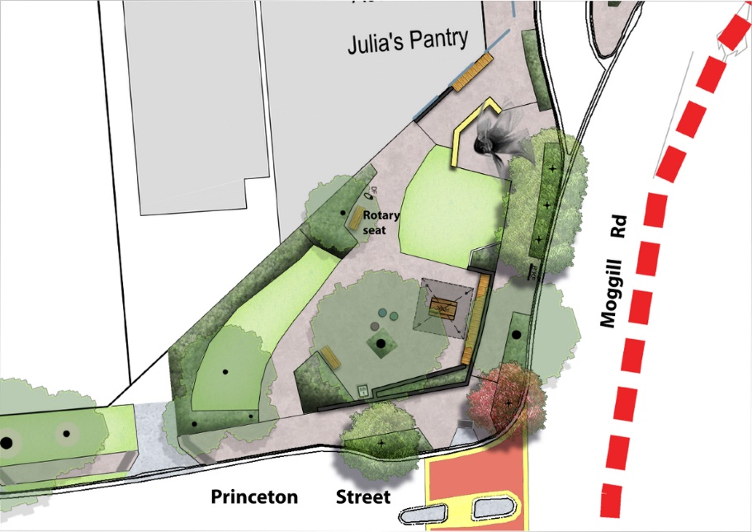
With member architect Ray Giarola, several commercial designs were costed, including the standard BCC design at $2000, and a modern, aesthetic, and robust design from Outdoor Structures Australia at Ipswich was selected. The model is called saltwater seat sw20- 2m long with spotted gum oil finished timber slats on a galvanised frame. This was also the lowest cost seat at $1355, assembled and delivered.
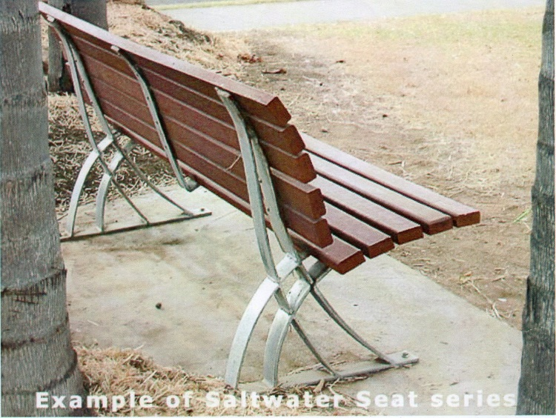
Various letter sizes were trialled for the timber slat sizes of 70mm and 140mm, and sizes were finally selected from trials at Giarola Architects using 40mm and 80mm Arial bold text.
Enquiries to the local men’s Shed established that they were not equipped to construct such a seat, but could possibly engrave it. However, to do our lettering, they would have to purchase jigs and letter templates, and were also not available to do the work to our timetable. Investigations were then made with laser burning companies to see if our hardwood slats could be laser burnt.
Burning our spotted gum hardwood by laser proved to be exploring new ground rarely attempted, but experienced firm Laws Laser at Geebung attempted it and provided samples of various depths for us on our timber samples for testing. At this stage, we did not have a final quote for the laser lettering, but estimated the total cost would come in under $2000.
Approval and Final Design.
BCC gave formal approval for the selected seat in July 2014, and the next Club Board 2014/15 under President Alan Biggs gave approval for $1700 to be spent on the project subject to a final quote on the laser lettering for the correct depth. In Sept. 2014, an order was placed for the seat with Outdoor Structures of Ipswich, and site visits were made to liaise with the manufacturer, and several to Geebung for the laser cutting by Laws Laser. Some difficulty followed in obtaining the final lettering software suitable for the laser machine, and help was obtained from Tim McGuire, Westside Stationary who was able to produce the final lettering in Corel draw with the Rotary logo in vector. The final design of the lettering resulted in the max depth burn being required to ensure long term durability, and an extension of approved total costs was given to $1899 as follows;
Seat $1284 + Delivery $71 + Lettering Drafting $60 +Laser Letters $484 = Total $1899
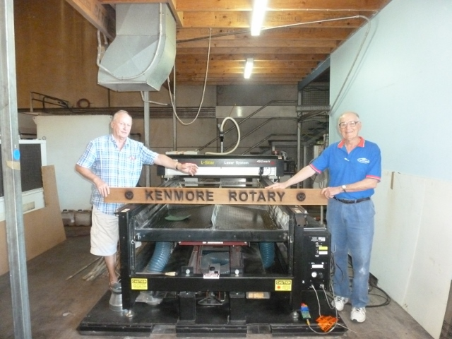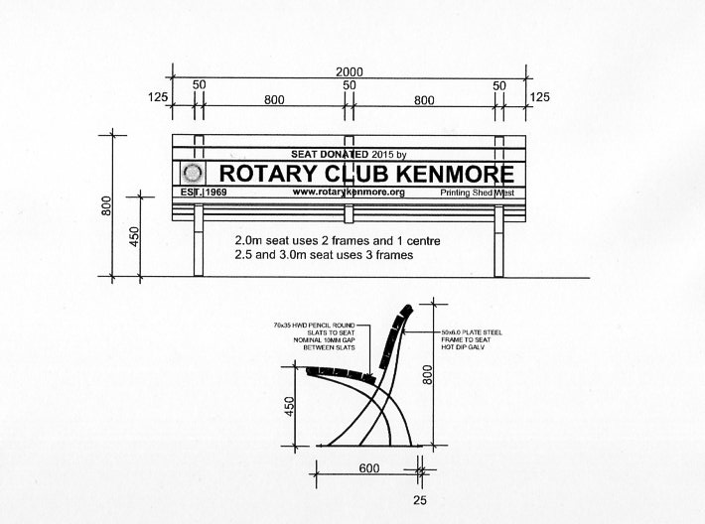
As well, the BCC also gave final location approval for the seat in a central location in Wal Cocking Park, facing Moggill Rd, and under the shade of an established tree. This location is also close to the signature sculpture “Growth” by Mathew Harding commissioned for the area, which has become the central focal point of the SCIP project.

Delivery.
The seat was delivered to my address at Kenmore in Dec 2014 with all plain timber slats attached. Member Barry Wheeler and I then detached all the 3 slats requiring laser burning, and delivered them to Laws Laser at Geebung, which was carried out quickly before their Christmas break. The finished lettering was then reassembled at Kenmore, given final oil coatings with Tannacoat finish by Koppers Arch, and wrapped and stored at my address. It was collected by the BCC erection team in early June when they erected the seat in the final location at no cost to the club, but kept it wrapped ready for the unveiling in July 2015.
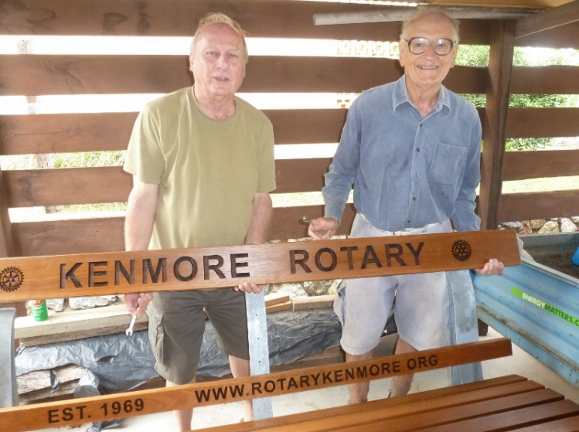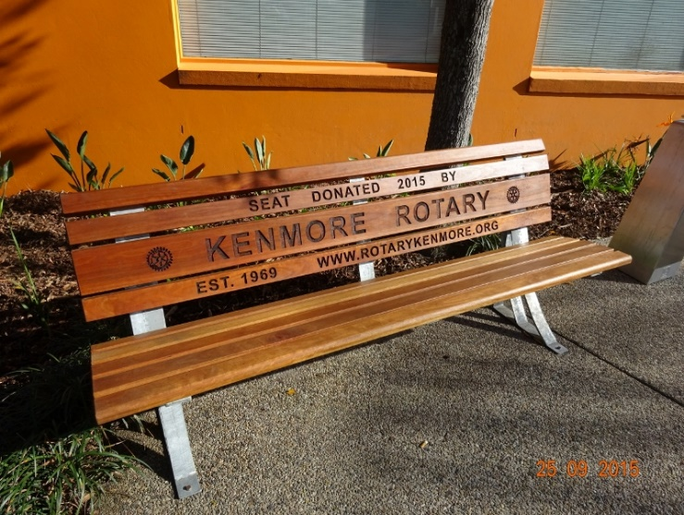

SCIP Project Timetable.
The Planning and consultation phase went the full year 2014, and construction started in January 2015. Both Barry and I attended the BCC Steering Committee meetings for planning the opening in July 2015, to be conducted by the Lord Mayor. A mid- winter festival theme with traders, music, and SCIP inspection was adopted and all local citizens were invited, with emphasis on the local traders who were actually making rate contributions to some of the SCIP cost. Rotary were invited to hold a sausage sizzle and to promote the club, and plans were made for an official unveiling by Cr. Margaret de Witt representing the Mayor. Margaret at that time was an hon. member of our club. This gave Rotary a splendid opportunity for promotion to the general community.
Opening
The official opening was on July 25th, 2015 while I was overseas, with the club involvement in the Mid-Winter Festival Day at the venue which also included a Rotary Sausage Sizzle. Cr. Margaret de Witt performed the official opening of the seat in the absence of the Lord Mayor, which was just one part of the activities, and Barry Wheeler’s report on the opening is as follows:
On the day a small, but select team of experienced Rotarians, led by David Lock, managed the logistical tasks of equipment loading and unloading within the tight timeframes laid down by BCC due limited unloading zone space.
By midday we were cooking and ready for the rush of hungry humanity. It is estimated about 1,200 locals attended and we sold out early, which was not surprising given that we were selling at $2.50 in competition with several local traders selling more sophisticated burgers in the $14-15.00 range. The lesson for next time is…higher price, more sausages!
Nevertheless, having decided that this event was not a charity fund raising activity, but a club promotional event, the net proceeds of $430 provided a much-needed boost to the club funds.
President Patrick Cook took full advantage of his 3min slot on the main stage to promote the club and formally present the commemorative seat which was then launched by our enthusiastic supporter and local BCC Councillor, Cr Margaret de Wit, in true Hollywood style (captured in the photo attached).
It was a great day and a highly visible community service project for Kenmore Rotary.
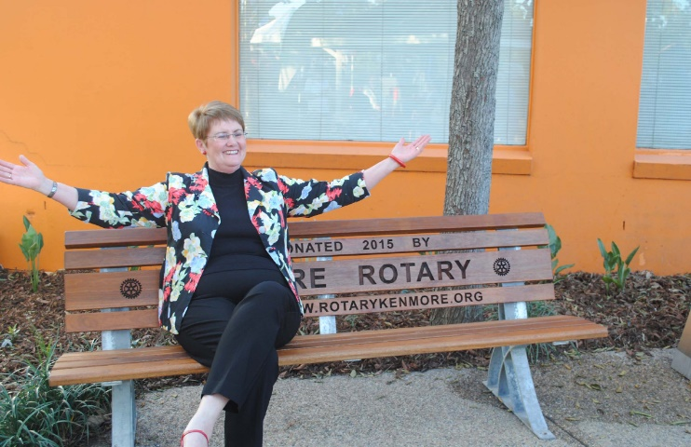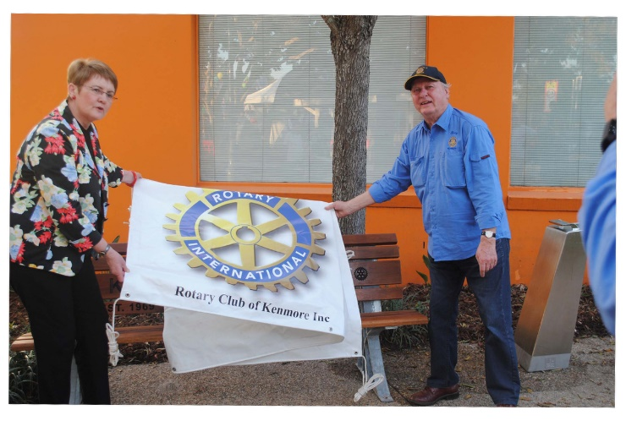
Maintenance.
The BCC erected several other timber seats of their own design which they stain every few years with a different finish. By recommendation from the manufacturer, the spotted gum Rotary seat was treated with Tannacoat which had good penetration and inhibited mould growth. The BCC used a different timber stain on their seats, so it was agreed for Rotary to maintain their own seat. After 4 years of annual staining, when the supply of Tannacoat ran out, a translucent wood stain made by Sikkens -Cetol HLse pine colour was used. The words were originally in burnt black with a good contrast with the fresh timber, but by 2020 as the seat colour darkened, it was decided to paint the letters in white to render them more readable from the street with help from former club member Richard Walton.
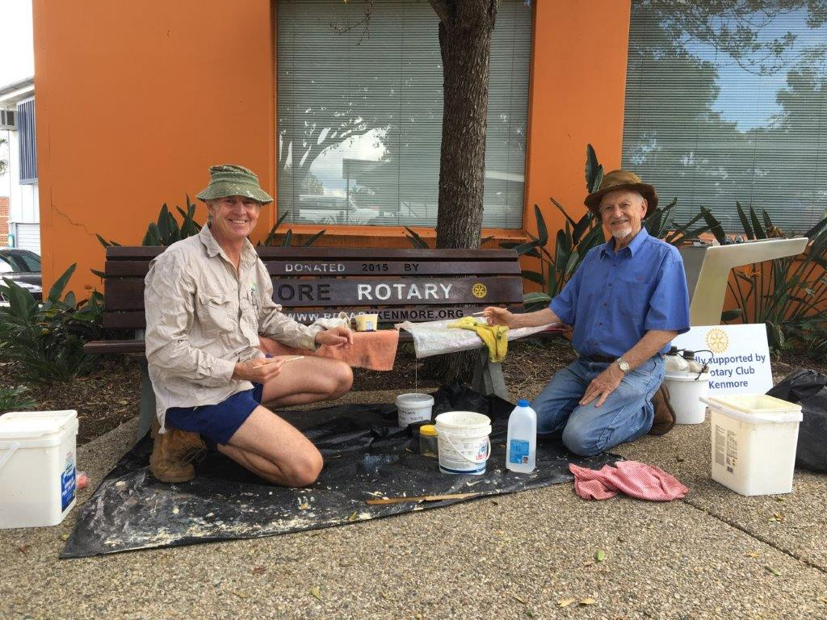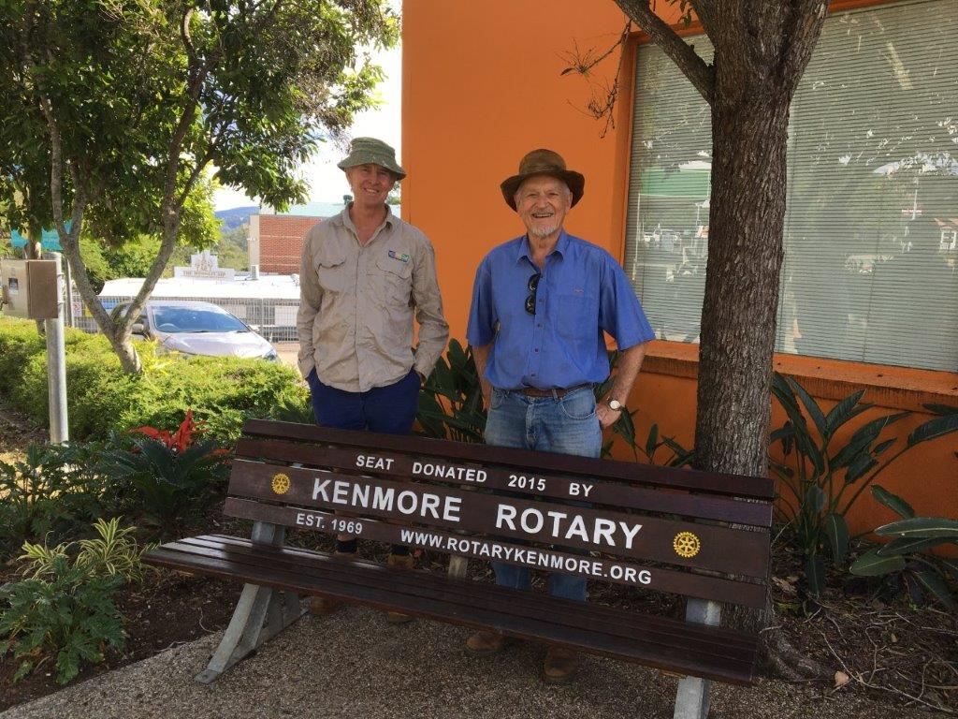

Conclusion
The seat project evolved over 3 rotary years from Oct 2013 to July 2015, and it appeared to be going on forever. However, by getting involved very early, we became the only local service club to actually have a community amenity with Club signage erected in a public place in Kenmore in a very central location. It is used regularly being close to local eateries and a water bubbler outlet, and it gives the club a permanent place of visibility with the Kenmore community and club contact details.

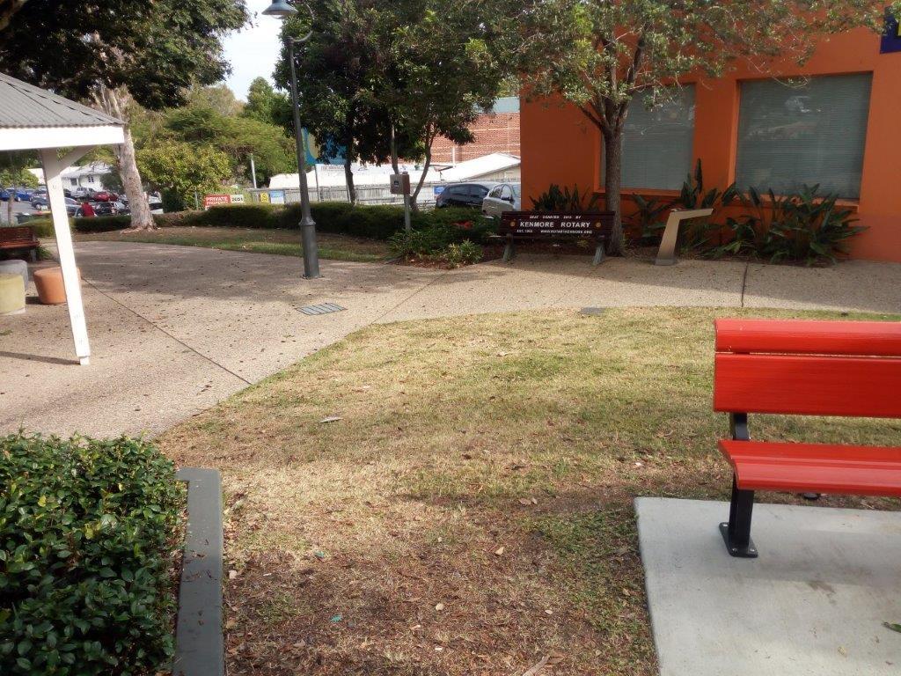

Brian Becconsall -21-12-2022 --Member Kenmore Rotary Club 1992- 2022

