KENMORE ROTARY Youth Services 2021-22
Rotary believes in developing the next generation of leaders. Our programs help younger leaders build leadership skills, expand education and learn the value of service.
During the financial year, 2021-22, the Rotary Club of Kenmore participated and achieved in the following strategic focus areas regarding Youth Services:
Building STEM Capacity for Tomorrow
Club Support: Key Outcomes:
NATIONAL YOUTH SCIENCE FORUM (NYSF)
Rotary Clubs select senior high school students for a two-week science & technology experience at Australia’s leading institutions in Canberra. The program fosters greater knowledge of, and passion for science and technology.
One Student - Nizar Badruddin Isani
Our student reported to have been impacted by this program in the following ways:
- • Ability to participate in tours of science and technology facilities in Canberra,
- • Learnt about cutting edge research happening in Australia,
- • Engaged with industry partners and research providers, which allowed for networking
opportunities,
- • Learnt about university and STEM career pathways,
- • Mixed with other like-minded students from all over Australia, and
- • Networked with former NYSF participants to further increase understanding of STEM-
related study and career experiences.
ROTARY YOUTH LEADERSHIP AWARDS (RYLA)
RYLA is a week-long live in Training Seminar sponsored by Rotary Clubs and/or Employers. RYLA promotes citizenship, personal development and leadership to young people aged 18 – 26 years. It aims that young people will gain skills to facilitate positive change in the world.
One participant – Evan Lendich
Our supported participants reported to have been impacted by this program in the following ways:
  - • Meet a lot of people,
  - • Learnt to speak up and with confidence,
  - • Public speaking skills and opportunities,
  - • Personal growth, and
  - • Learnt to push themselves into activities they never would have considered joining
prior to RYLA.
Youth Leadership
Club Support:
Key Outcomes:
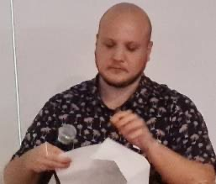
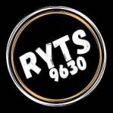
Club Support:
Key Outcomes:
ROTARY YOUTH TRANSISTION SEMINAR (RYTS)
RYTS is a week-long live in Training Seminar sponsored by Rotary Clubs and/or families. Through a series of life skills sessions, RYTS will equip school leavers with the confidence to step out into the real world.
One Student - Aditee Srinivasan age 18, graduated from St Peters Lutheran college
In addition to inviting our financially supported young person, the club also requested two other local students (Emily Loff and Raghav Menon) to share their journeys on the RYTS course at a Club meeting held on the 15th February, 2022.
Our supported participants reported to have been impacted by this program in the following ways:
- • Multiple areas of personal growth,
- • Built and improved teamwork skills,
- • Raised self-awareness,
- • Practical skills for adult life,
- • Improved decision making,
- • Develop lifelong friendships and connections with other participants,
- • Participated in activities that challenged and pushed beyond their comfort zone on
Aditee expressed her gratitude to the Rotary Club of Kenmore and, in particular, Urvi Shah. She said her week at RYTS had been a magical experience. The best feature of the RYTS camp was the element of surprise. She described the different theme of each day of the program. She observed that nothing was done by the leaders without a good reason.
Raghav gave further description of the daily themes and challenging activities which he enjoyed very much.
many different levels, and
• Exposed to inspiring guest speakers.
Emily thanked RC Goodna for sending her along to RYTS and the Kenmore club for the opportunity to share her experiences and learnings. Emily gave a powerful presentation in which she explained how the program had affected great personal growth for her. “The camp taught me who I am.”
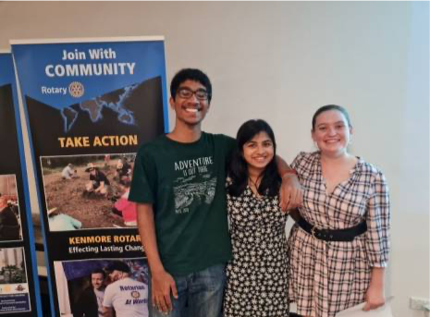
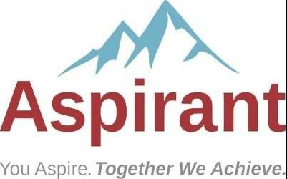
Club Support:
Key Outcomes:
SENIOR AND JUNIOR LEADERSHIP ASPIRANT STUDENTS
A specifically designed course, delivered to Year 11 students, aims to impart knowledge and skills related to leadership, personal growth, and reflective skills.
35 x Kenmore State High School Year 11 students
Delivered by Ken Gilbert and supported by other Club members
Our supported participants reported to have been impacted by this program in the following ways:
- • Personal Presentation: Stance, dress, entrance and approach skills, working a group or a room,
- • Communication skills: speaking publicly and personally; listening; responding for understanding including using paraphrasing,
- • Time management skills and the use of sharing responsibility and delegation,
- • Emotional Intelligence,
- • Understanding Self and Others: Use of The Myers Briggs Type Indicator (MBTI),
Sources of motivation: What’s in it for me (WIIFM): external and internal, positive and
negative motivation, Maslow and Herzberg,
- • Developing a picture of the sort of person I want to be: the concept of “personal
brand”, what is my uniqueness? Where, how and why I have become,
- • Optimism and Pessimism: learned optimism,
- • Responding to appreciation and criticism: giving positive and negative feedback to
other,
- • Group Leadership Skills, and
- • What is an ethical person? Servant Leadership.
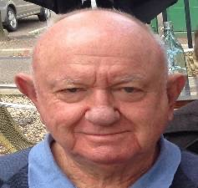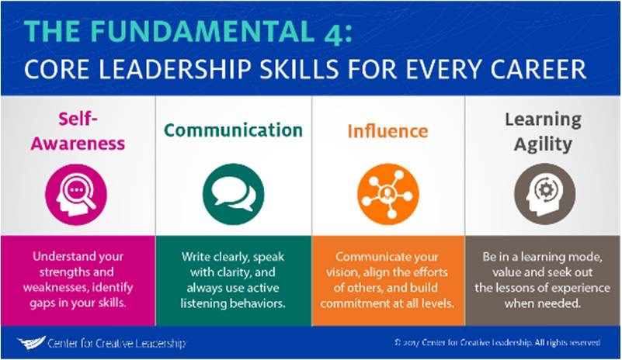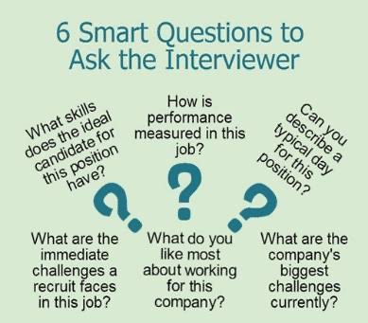
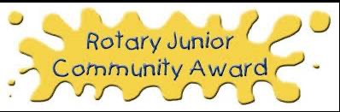
Club Support: Key Outcomes:
ROTARY JUNIOR COMMUNITY AWARDS
In order for you to achieve the Rotary Junior Community Award you must participate in activities of your choice in four areas: (1) Community Service; (2) Physical Recreation; (3) Social Experience; and (4) Skills.
16 x Chapel Hill State School students
Our supported participants reported to have been impacted by this program in the following ways:
- • Gained a prestigious award (similar to Duke of Edinburgh Award undertaken by secondary students)
- • Helped people in the community
- • Personal growth
- • Gratitude of needy people
- • Admiration from community leaders
- • Had fun
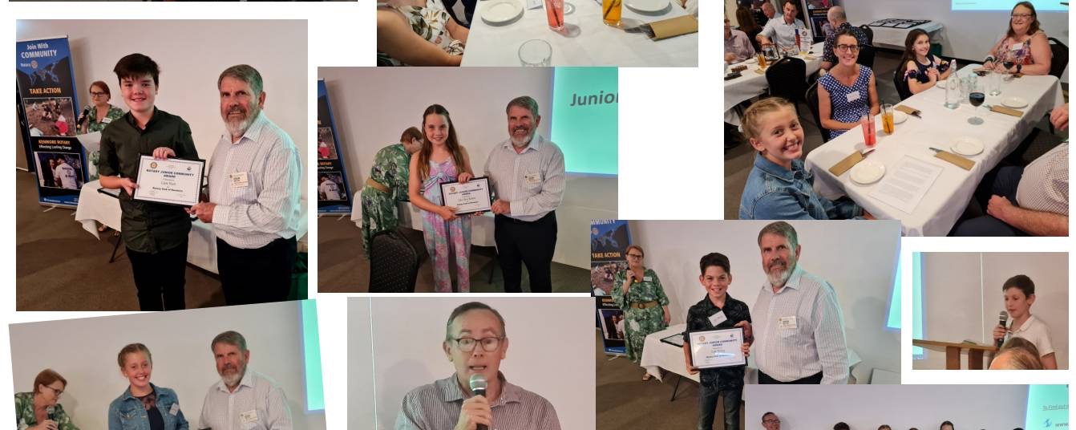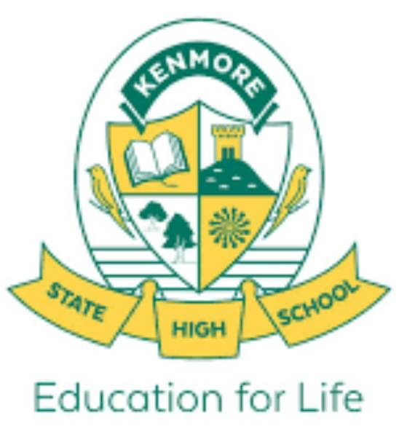
Club Support: Key Outcomes:
PREFECT INTERVIEWS
Kenmore Rotary Board members are invited to be on the interview and selection panel for the Year 11 students applying for the role of ‘Prefect’ in the following year’s Leadership Team.
Kenmore State High School Year 11 students for leadership positions in Year 12
Our supported participants reported to have been impacted by this program in the following ways:
- • Experience undergoing an interview,
- • Demonstrating leadership skills,
- • Opportunity for personal growth and communication skills development, and
- • Extending themselves regarding participating in a competitive process.

